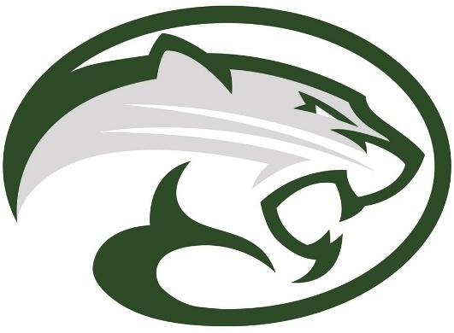
2018 Cougar Classic Golf Tournament

Dear Niwot H.S. Alumni,
On behalf of the Niwot High School Touchdown Club, we would like to invite you to join us as a sponsor/donor for our 2018 Cougar Classic Golf Tournament on August 3, 2018 at the Twin Peaks Golf Club in Longmont. The purpose of the event is to raise money for new CONCUSSION REDUCTION FOOTBALL HELMETS! We love our young men and want to keep them safe! Our goal is to outfit each one of them with the best equipment out there. We are expecting 144 golfers to participate, along with their families.
Please take a few minutes to read through our information and carefully consider whether your business can sponsor or donate to our event. Sponsorship is a great opportunity to advertise your company to the community! The sponsorship packages offer premium signage and advertising. Take a look and find the one that fits your business. All signs are provided by the Touchdown Club. You will also receive web advertising on our golf tournament website and our Facebook page, NIWOT HS COUGARS TOUCH DOWN CLUB. Detailed sponsorship information is attached.
If a sponsorship is not for you, we are looking for prize donations, gift cards or monetary donations. You will receive recognition for your donations during the tournament.
The Niwot Booster Club is supporting us by allowing use of their 501(c)(3) corporation and all donations and sponsorships are 100% tax deductible. For your tax purposes, The Booster’s EIN# is 41-2078067. Please have all donations made out to NHS Boosters, Attention TD Club. Give us a call with any questions you may have.
We look forward to working with you and appreciate your consideration!
Thank you and GO COUGARS!

Lisa Coblentz Linda Herring Fransean Molina
303-881-8978 303-532-6292 720-364-8295

