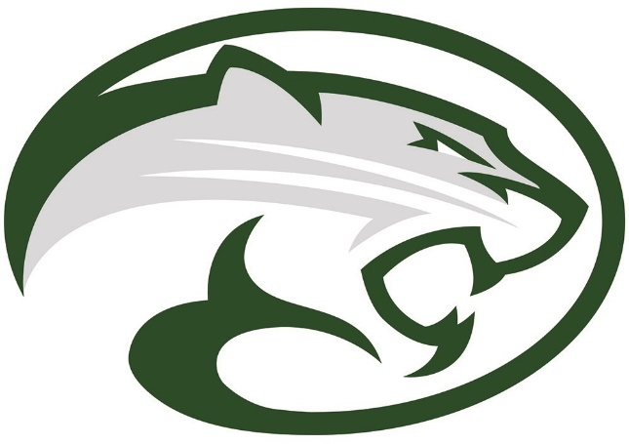

Sponsorships available
2018 Cougar Classic Golf Tournament

Thank you Pollard Jeep for sponsoring our hole in one!!
Platinum Hole in One Car Sponsor
- Corporate recognition at awards reception
- Hole sponsor with tee-box signage
- Advertising on the Niwot Football Website year round
- Your corporation announced during the home football games
- A signed football and Team picture to display at your place of business.
- Golf Cart advertising

Thank you Sierra Instruments for being one of our Defensive Sponsors!
We have 3 left, so hurry up and get on the Defensive Team
Defensive Sponsor $800
- One golf foursome (includes use of range, golf cart, lunch and award reception)
- Corporate recognition at awards reception
- Hole sponsor with tee-box signage
- Advertising on the Niwot Football Website year round
- Your corporation announced during the home football games
- A signed football and Team picture to display at your place of business.
- Golf Cart advertising

Offensive Sponsorship $800
- One golf foursome (includes use of range, golf cart, lunch and award reception)
- Corporate recognition at awards reception
- Hole sponsor with tee-box signage
- Advertising on the Niwot Football Website year round
- Your corporation announced during the home football games
- A signed football and Team picture to display at your place of business.
- Golf Cart advertising
Thank you Arrowleaf Landscape for sponsoring our SCORE! Beverage Cart!
SCORE!! Beverage Cart Sponsor $250 (one available)
- Corporate recognition at awards reception
- Signage/advertising on Golf Course beverage cart
- Advertising on the Niwot Football Website year round
- Your corporation announced during one of the home football games
- Golf Cart advertising
Special Teams Shared Tee Sponsor $200 (per company)
- Corporate recognition at awards reception
- Shared Hole sponsor with tee-box signage
- Advertising on the Niwot Football Website year round
- Your corporation announced during one of the home football games
- Golf Cart Advertising

Prize / Monetary Donations
We are also looking for donations of prizes, gift cards and monetary donations. You will receive recognition for your donations in all of our advertising outlets mentioned in the sponsorship details

Goody Bag Donations
We are looking for donations to fill goody bags for the participants of the event. We are expecting 144 adults for the tournament. You will receive recognition for your donations in all of our advertising outlets mentioned in the sponsorship details.

Donations should be made out to NHS Boosters, Attention TD Club
Thank you for supporting our Niwot High School Football Team!

